EXPERIMENT 14: ANALYSIS OF EDFA-BASED DENSE WDM LINK PERFORMANCE USING OPTISYSTEM
OBJECTIVES :
1. To design and simulate a Dense Wavelength Division Multiplexing (DWDM) optical communication system using OptiSystem.
2. To investigate the impact of varying optical fiber length on overall system performance.
3. To examine the effectiveness of an Erbium-Doped Fiber Amplifier (EDFA) in compensating for fiber a enuation losses.
4. To evaluate and compare received power, bit error rate (BER), and Q-factor across different fiber lengths.
SOFTWARE REQUIRED: Opti System.
CIRCUIT DIAGRAM:

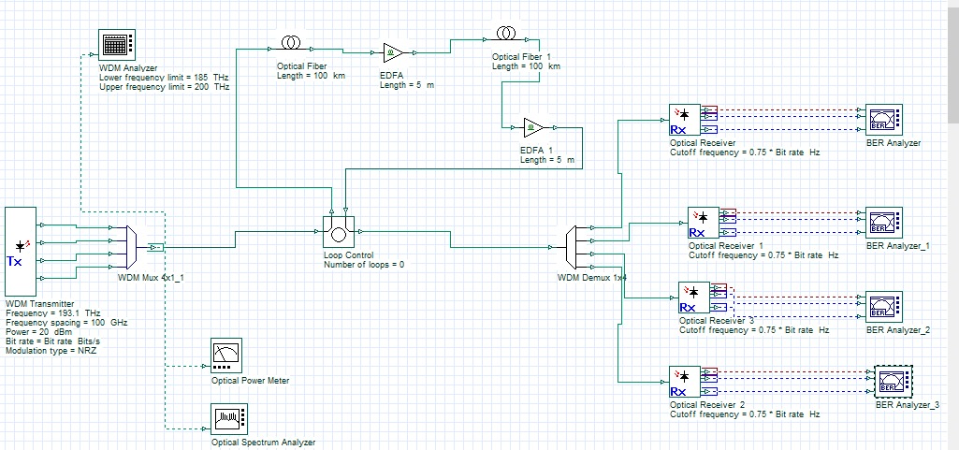

OUTPUTS:
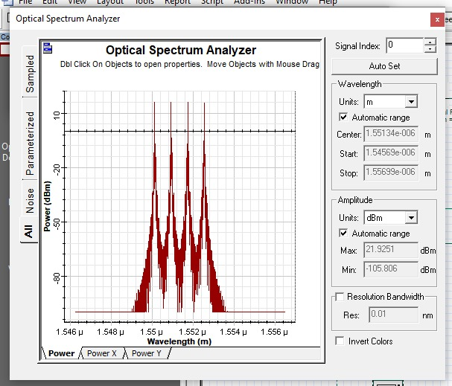 | 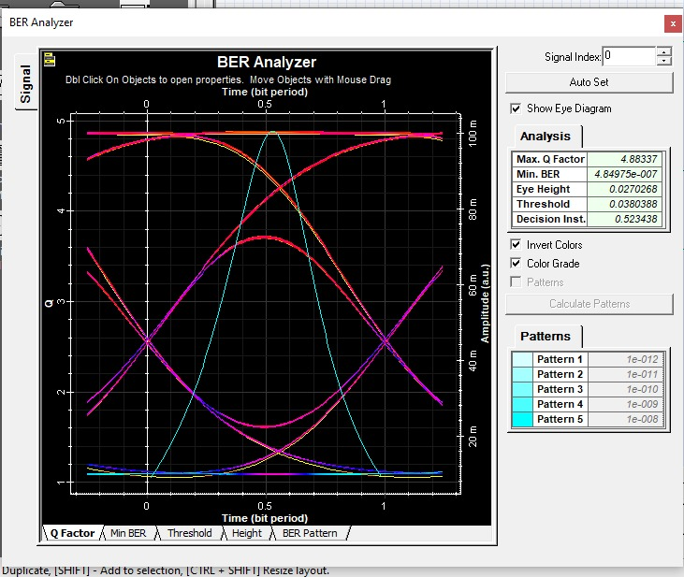
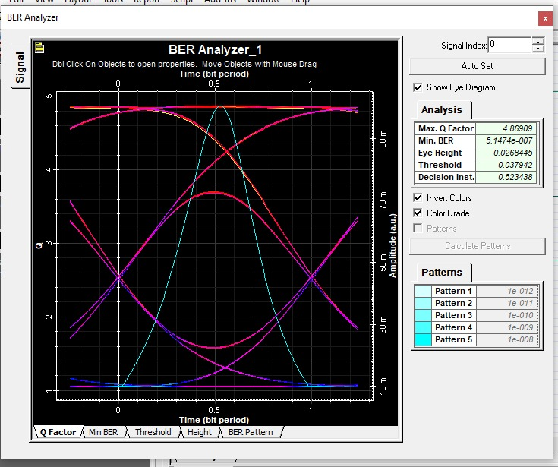 | 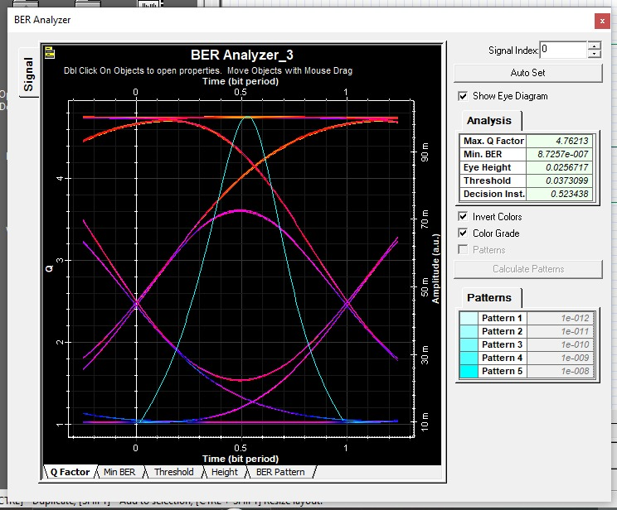
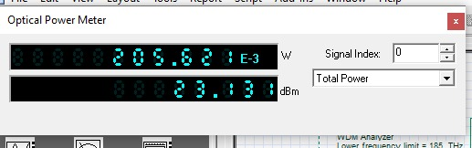

REFLECTION:

learned how multiple optical channels are transmitted through a single fiber using DWDM.
- I understood the function of an EDFA in compensating for fiber attenuation.
- I learned to analyze BER and Q-factor using BER analyzers.
- I understood how fiber length affects optical communication performance.

RUBRICS:

Objective | Assessment Criterion | Excellent – 4 | Good – 3 | Satisfactory – 2 | Needs  Improvement –  1 | Weightag  e
System Design  & DWDM  Setup | Correct selection and connection of OptiSystem components for the DWDM link (PRBS  Generator, NRZ  Pulse Generator, CW  Lasers, WDM  Multiplexer, Optical  Fiber, EDFA, WDM  Demultiplexer, PIN  Photodetectors, Low Pass Filters, BER Analyzers). | All four transmiLer channels,  multiplexer, fiber, EDFA,  demultiplexer and receiver chains are correctly selected, connected in sequence and configured without errors. | All components are present with minor connection or layout errors,  but the DWDM link remains functional. | Component  selection is partially complete; missing receiver chains or EDFA placement errors impede signal flow. | Incorrect component selection or improper setup leading to complete simulation failure. | 20%
Parameter  Configuration  & Execution | Accurate setup of input parameters: Transmit Power (20 dBm), Center Frequency (193.1  THz), Channel  Spacing (100 GHz),  Fiber Length (50 km, 75 km, 100 km) and Loop Control (0). | All input parameters and fiber-length test cases are accurately set and executed, with and without the EDFA. | Test case parameters are mostly accurate with minor seLing discrepancies. | Basic parameters are configured, but multiple fiber-length cases or the  with/without EDFA  comparison are missing. | Incorrect parameter seLings or failure to run the required test cases. | 20%
Measurement  & Performance  Monitoring | Accurate extraction and recording of Min BER, Max QFactor, received power, optical spectrum and eye diagrams for all channels and fiber lengths. | Precise data extraction across all fiber lengths, neatly tabulated with complete BER, Qfactor and power readings and clear spectrum/eye diagrams. | Data is collected with minor omissions in BER, Q-factor or power readings. | Partial data collection with incomplete tables or missing spectrum/eye diagram captures. | Inaccurate, incomplete or missing data  and measurements. | 20%
Amplification  & Fiber Loss  Analysis | Detailed evaluation of fiber aLenuation, dispersion, EDFA gain and noise, and the effect of amplification on received power, Qfactor and BER. | Comprehensive  analysis correctly relating fiber length, aLenuation and EDFA compensation to received power, Q-factor and BER, with and without amplification. | Clear analysis identifying basic trends in power, BER and Q-  factor relative to fiber length and EDFA use. | Basic aLempt at result analysis without explaining physical mechanisms such as aLenuation, dispersion or amplifier gain. | Erroneous or missing analysis of simulation results. | 20%
Report & Conclusion | Identification of the benefit of EDFA amplification, achievable transmission distance, trade-offs (amplifier noise, channel spacing), structure and clarity of the report. | Report features clear spectra and eye diagrams, complete result tables and insightful  conclusions identifying optimal operating parameters for the DWDM link. | Satisfactory report with relevant displays and a sound concluding summary. | Incomplete report with missing graphs,  readings or weak conclusions. | Disorganized or incomplete report lacking required diagrams and  valid conclusions. | 20%

CONCLUSION :
The DWDM optical communication system was designed and simulated successfully using OptiSystem. The performance of the link was analyzed for different fiber lengths, and the role of the EDFA in compensating for fiber attenuation was studied. The BER and Q-factor results were recorded to evaluate signal quality. The experiment demonstrated the importance of optical amplification in long-distance, high-capacity optical communication systems.

